**HAMMAD MURTAZA**

**SID: 11146**

**CID: 107241**

**OS LAB 9**

**Q1:**

**CODE:**

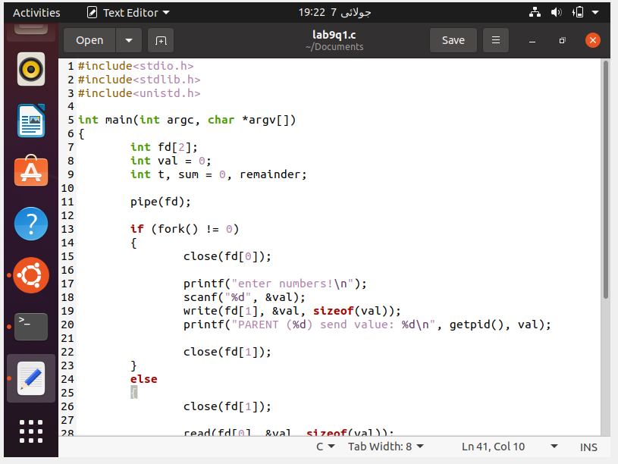

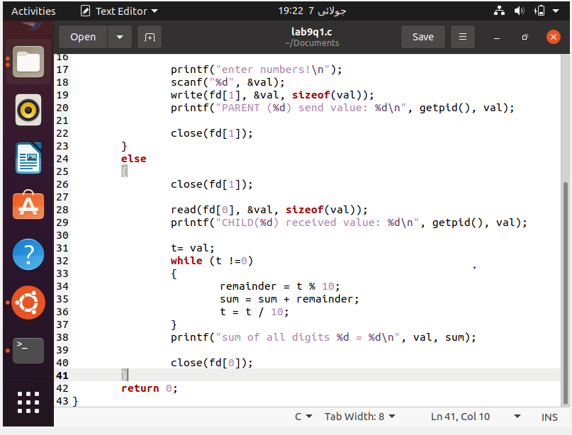

**OUTPUT / SCREENSHOTS:**

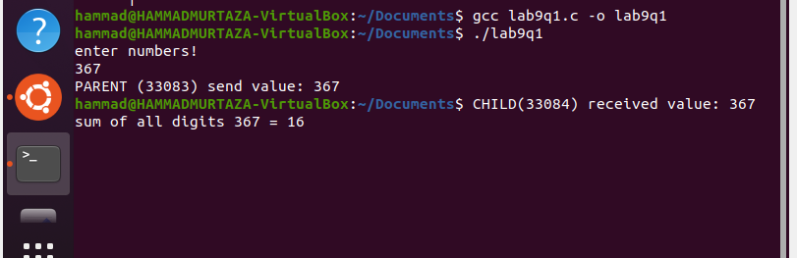

**CLASS TASK:**

**CODE:**

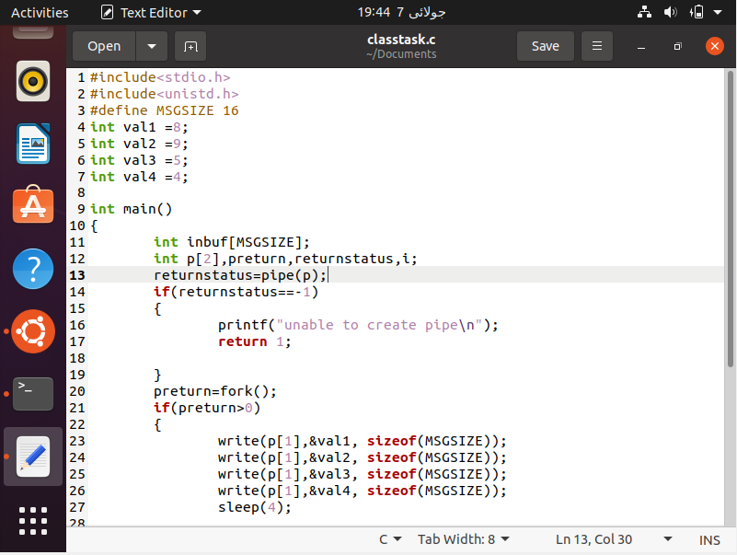

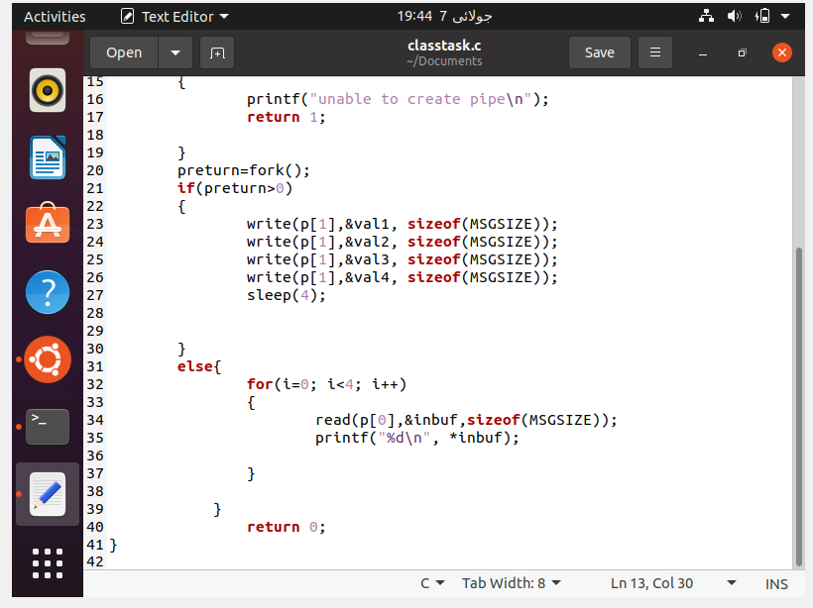

**OUTPUT / SCREENSHOTS:**

